Livrable : Lab 1
ETTALIBI Assia
groupe : The AFCE Sparks

Deliverable 1 : Part 1
Spark Master UI Screenshot Must show 1 master + 1 worker connected Must show cores and RAM recognized by the worker

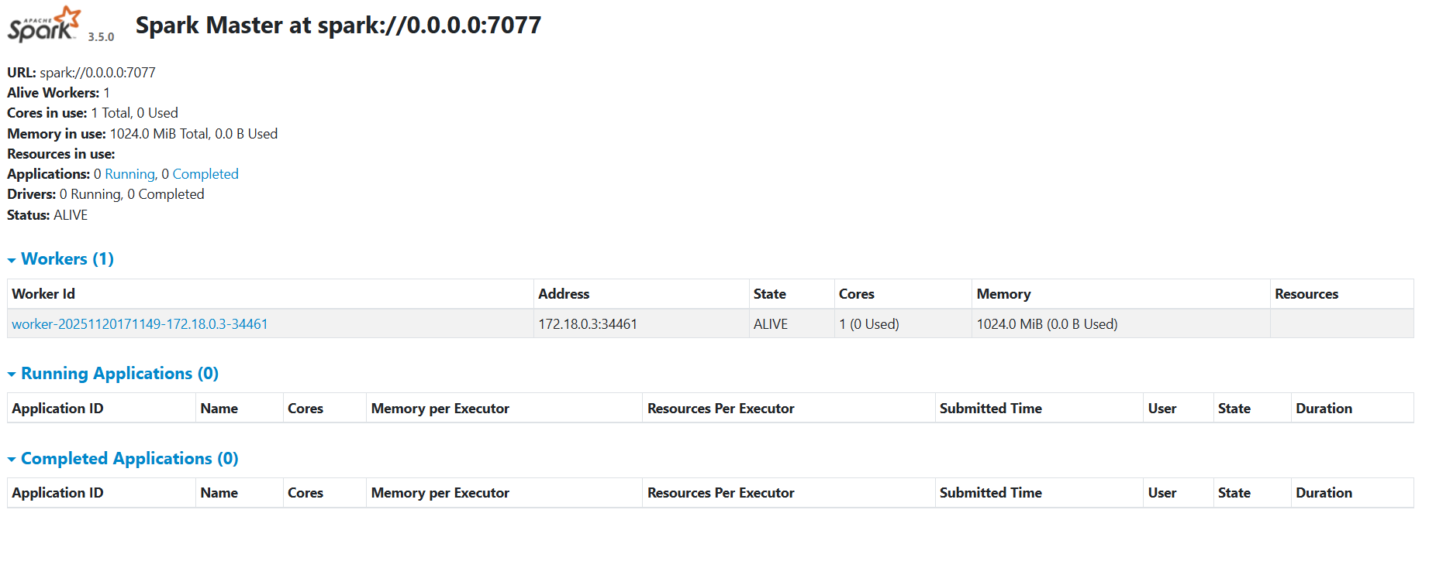
Delivrable 2 : Part B & C
Terminal Output of Your Spark Application Full output of running lab1_hello_spark.py
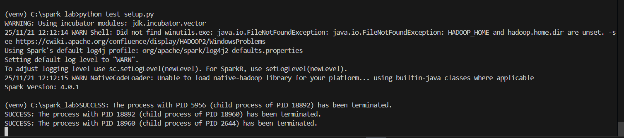

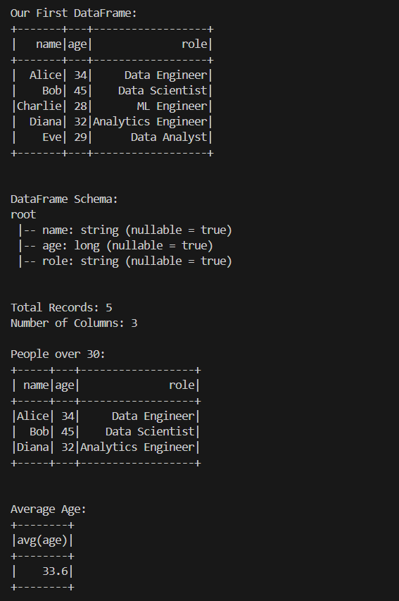

Delivrable 3 : Part D
Spark Application UI Screenshots
Jobs tab
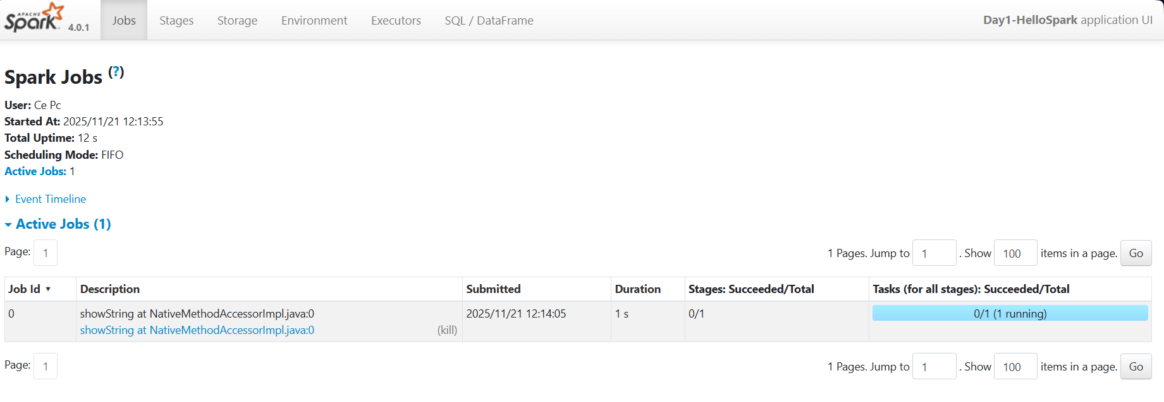
One DAG visualization
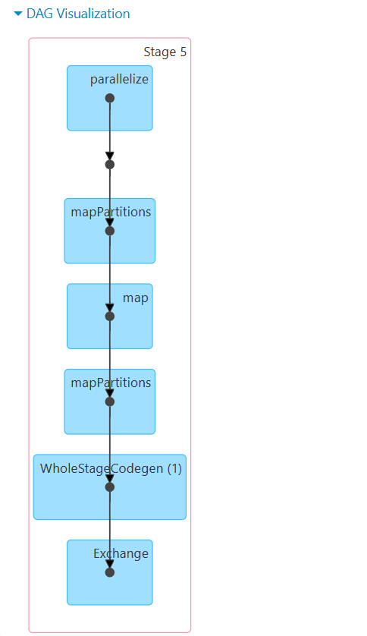

Stage details for any stage

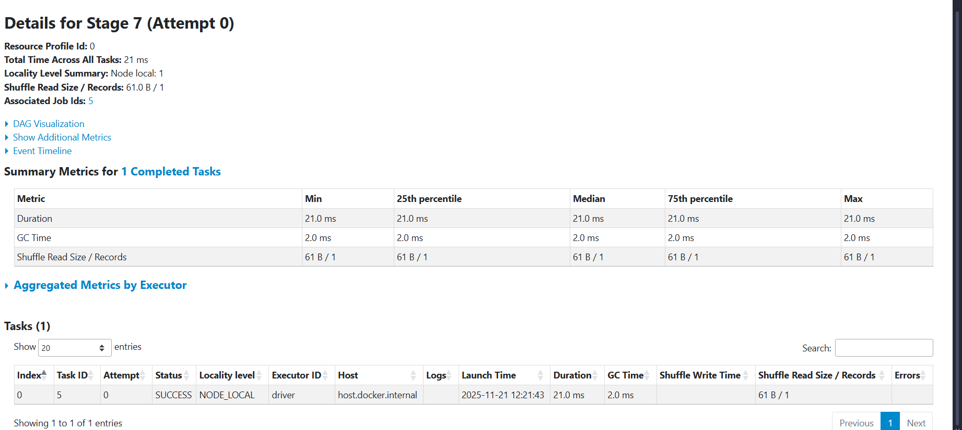
Executors tab

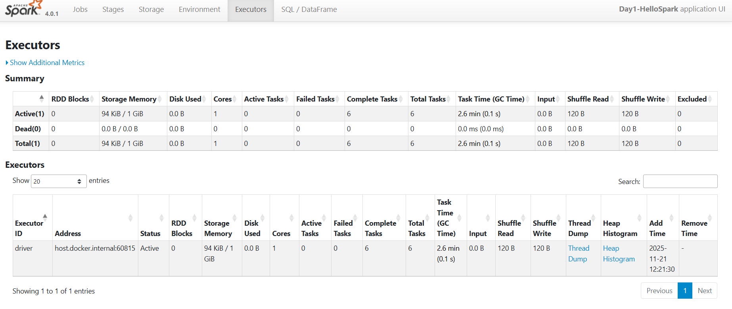
Delivrable 4
- DAG : directed Acyclic Graph , it represents the execution plan that Spark uses to process data and it represented as a graph
- there is 4 stages because we have 4 execution stages : df.show() , df.count() df.filter(...).show() , df.agg(...).show()
- the number of tasks per stage related to the number of partitions , but since the stages in our application is small it is 1 task per stage
- on the executors tab i noticed a table of the summary that represent the storage memory , how many cores , the tasks completed with their time , the amount of data that shuffled on read and on write , it is also a table of the executor details

